Week-5
1# Perform a basic SWOT analysis (Strengths, Weaknesses, Opportunities, Threats) for a sample organization's IT security setup.
Basic SWOT Analysis of a Sample Organization’s IT Security Setup

Sample Organization Context:A mid-sized company with:
- Firewall protection
- Antivirus software on endpoints
- Basic password policies
- Cloud-based email system
- Small internal IT team
Strengths
- Firewall Protection: Prevents unauthorized external access.
- Antivirus/Endpoint Protection: Protects against common malware and viruses.
- Regular Data Backups: Reduces risk of permanent data loss.
- Cloud Email Security: Cloud provider offers spam filtering and encryption.
- Basic Access Controls: Password authentication for internal systems.
Weaknesses
- Weak Password Policies: No enforcement of multi-factor authentication (MFA).
- Limited Security Monitoring: No dedicated Security Operations Center (SOC).
- Outdated Software: Some systems not regularly patched.
- Lack of Security Awareness Training: Employees vulnerable to phishing attacks.
- No Intrusion Detection/Prevention System (IDS/IPS).
Opportunities
- Implement MFA: Improve authentication security.
- Security Awareness Training: Reduce phishing risks.
- Deploy SIEM System: Centralized logging and monitoring.
- Cloud Security Enhancements: Use zero-trust architecture.
- Penetration Testing & Audits: Identify hidden vulnerabilities.
Threats
- Phishing Attacks
- Ransomware
- Insider Threats
- Data Breaches
- Zero-Day Vulnerabilities
- DDoS Attacks

2# Write a program to simulate simple brute force attack. Try to crack numeric passwords of length 4,6 and 8 digits.
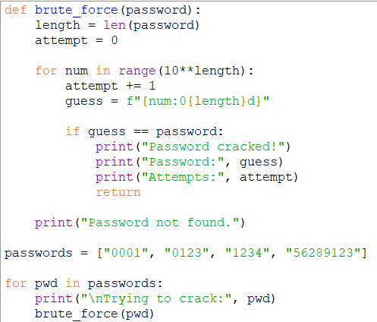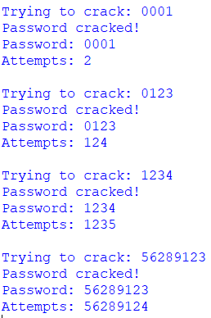
3# Install Kali Linux in your USB drive and demonstrate booting of the system using it. Write all the steps with proper screenshots.
Requirements:
- USB drive (minimum 8GB recommended)
- Kali Linux ISO file
- Rufus (Windows) or Balena Etcher
- A computer that supports USB boot
Step 1: Download Kali Linux
- Go to https://www.kali.org
- Download the latest Kali Linux ISO (64-bit Installer)
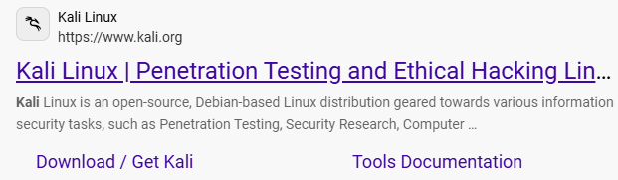
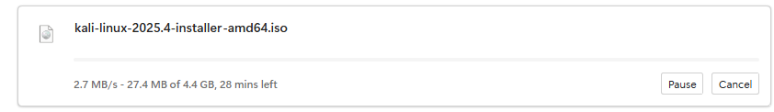
Step 2: Download Rufus (For Windows)
- Go to https://rufus.ie
- Download and open Rufus (no installation required)
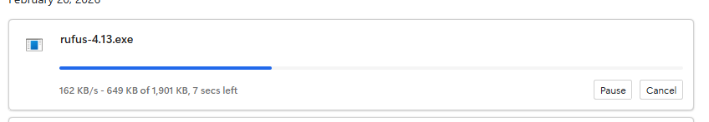
Step 3: Create Bootable USB
- Insert USB drive
- Open Rufus
- Select:
  - Device → Your USB
  - Boot selection → Select Kali ISO
  - Partition scheme → MBR (or GPT depending on system)
- Click Start
- Wait until process completes
Step 4: Boot from USB
- Restart computer
- Press Boot key (F12 / F9 / ESC / DEL depending on system)
- Select USB device
- Choose:
  - “Live system”
OR
  - “Graphical Install”
Step 5: Install Kali (Optional)
- Choose Graphical Install
- Select language
- Configure network
- Set username/password
- Select disk (USB for persistence if desired)
- Complete installation
4# Demonstrate the working of Wireshark tool to capture a sample TCP/IP packet details in Kali Linux. Write all steps with proper screenshots.
Step 1: Open Wireshark
- Boot into Kali Linux
- Open terminal
- Type:
- wireshark
OR open from Applications → Sniffing & Spoofing → Wireshark
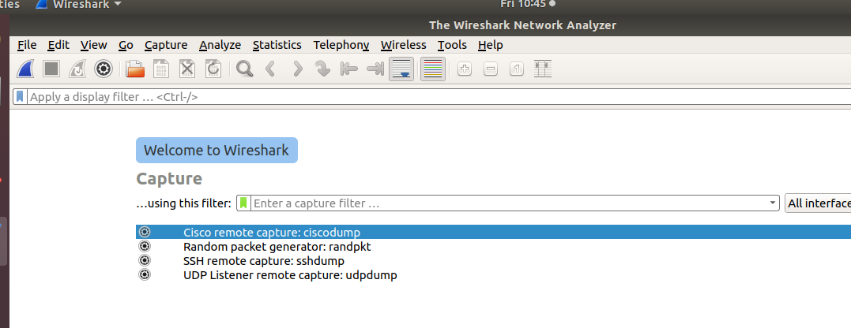
Step 2: Select Network Interface
- Choose:
  - eth0 (wired)
  - wlan0 (wireless)
- Double-click the active interface
Step 3: Generate Traffic
To capture packets:
- Open browser
- Visit a website (e.g., example.com)
- Or ping a server:
- ping google.com
Step 4: Filter TCP Packets
In filter bar, type:
tcp
Press Enter.
This shows only TCP packets.
Step 5: Inspect a Packet
- Click on a TCP packet
- Expand:
  - Ethernet II
  - Internet Protocol (IP)
  - Transmission Control Protocol (TCP)
You can view:
- Source IP
- Destination IP
- Source Port
- Destination Port
- Sequence number
- Flags (SYN, ACK, etc.)
Example TCP Handshake in Wireshark
You may observe:
- SYN
- SYN-ACK
- ACK
This confirms TCP 3-way handshake.

